

Practices for Secure Software Report

Table of Contents
Document Revision History 3
Client 3
Instructions 3
Developer 4
1. Algorithm Cipher 4
2. Certificate Generation 4
3. Deploy Cipher 4
4. Secure Communications 4
5. Secondary Testing 4
6. Functional Testing 4
7. Summary 4
8. Industry Standard Best Practices 4

Document Revision History

Version | Date | Author | Comments
1.0 | [Date] | Jason Wick

Client



Instructions

Submit this completed practices for secure software report. Replace the bracketed text with the relevant information. You must document your process for writing secure communications and refactoring code that complies with software security testing protocols.

- Respond to the steps outlined below and include your findings.
- Respond using your own words. You may also choose to include images or supporting materials. If you include them, make certain to insert them in all the relevant locations in the document.
- Refer to the Project Two Guidelines and Rubric for more detailed instructions about each section of the template.

Developer
Jason Wick

Algorithm Cipher

AES-256 is the recommended encryption algorithm cipher for Artemis Financial because it provides strong security, high performance, and wide industry acceptance. AES (Advanced Encryption Standard) is a symmetric encryption algorithm that protects sensitive financial data by converting readable information into unreadable ciphertext using a secret key. It is trusted by banks, governments, and major organizations around the world.
AES supports key sizes of 128-bit, 192-bit, and 256-bit. AES-256 is the strongest option because it uses a 256-bit key, making brute-force attacks extremely impractical. For data integrity, SHA-256 hash functions can be used to generate a unique checksum value for data. If the data changes, the hash value also changes, helping detect tampering.
Random numbers are important in encryption because they are used to generate secure keys, initialization vectors, and session values. Strong randomness improves protection. Symmetric encryption uses one shared key for encryption and decryption, making it fast and efficient for large data transfers. Non-symmetric (asymmetric) encryption uses two keys: a public key and a private key. It is commonly used for certificate exchange, digital signatures, and secure key sharing in HTTPS connections.
The history of encryption started with simple manual ciphers and later moved to digital standards such as DES and 3DES. As computing power increased, older methods became weaker. AES replaced older standards and is now the modern global standard for secure encryption. Today, organizations combine AES, SHA-256, TLS/HTTPS, and certificate-based security to protect systems and customer information.

Certificate Generation
Insert a screenshot below of the CER file.

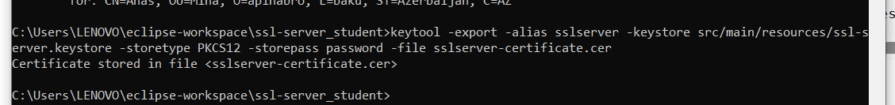
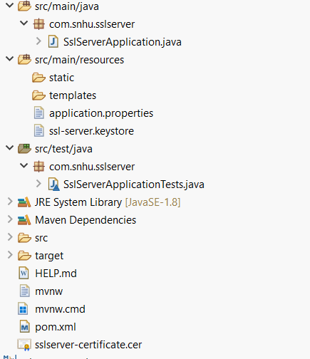

A self-signed SSL certificate was generated using the Java keytool utility and stored in the project keystore file. This certificate enables HTTPS communication on port 8443 by encrypting data sent between the browser and the application. It was used for local development and testing to demonstrate secure communications.

Deploy Cipher
Insert a screenshot below of the checksum verification.

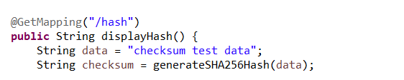
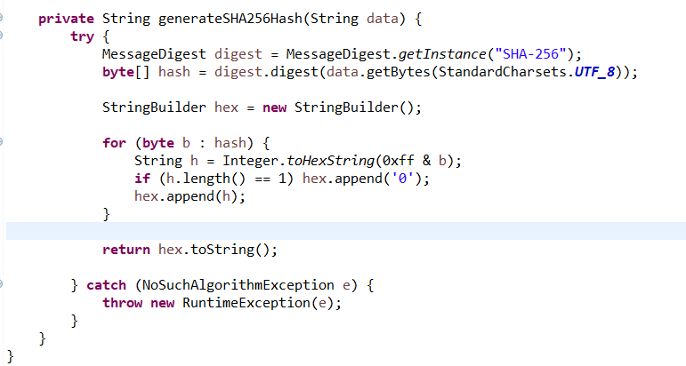

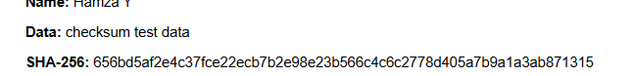
The checksum verification was implemented in the Java application by creating a SHA-256 hashing method. The /hash endpoint generates a SHA-256 hash from a sample data string and displays the result in the browser. This demonstrates how data integrity can be checked by comparing the original data with its generated checksum.

Secure Communications
Insert a screenshot below of the web browser that shows a secure webpage.

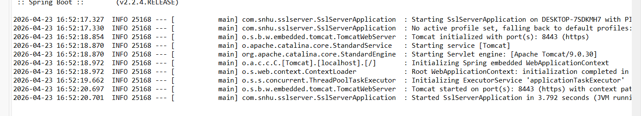
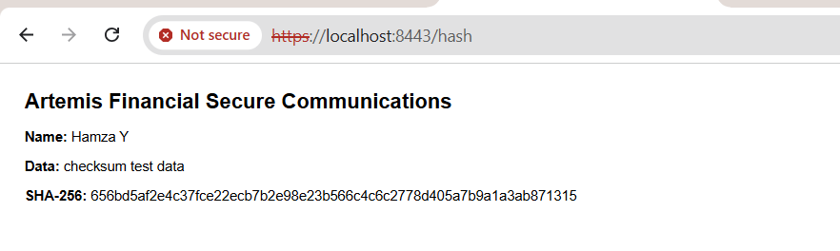
The application was successfully configured to use HTTPS on port 8443 with a self-signed SSL certificate. Although the browser still displayed a “Not secure” warning, this occurred because the certificate was self-signed and not issued by a trusted public certificate authority. The use of HTTPS and the configured keystore still demonstrate secure communication for local development and testing purposes.

Secondary Testing
Insert screenshots below of the refactored code executed without errors and the dependency-check report.
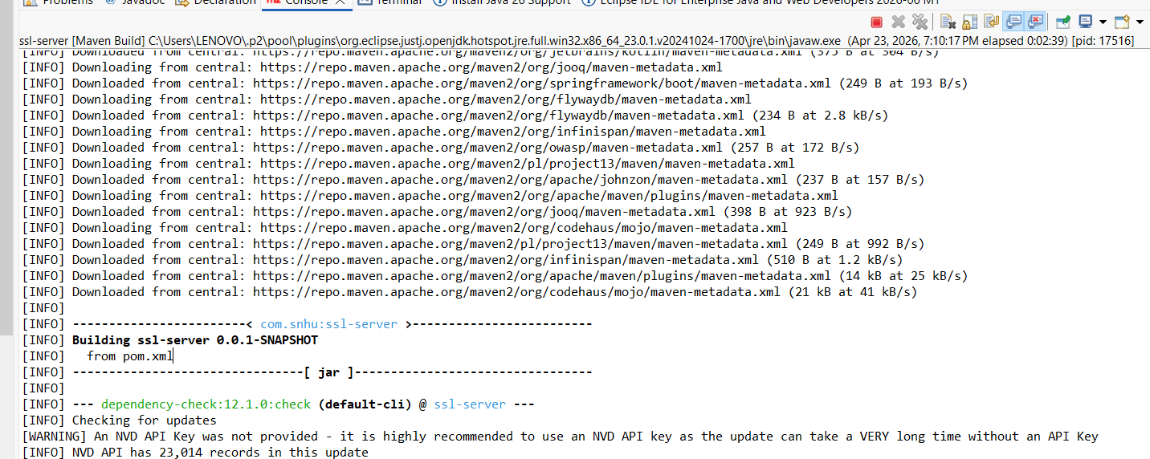
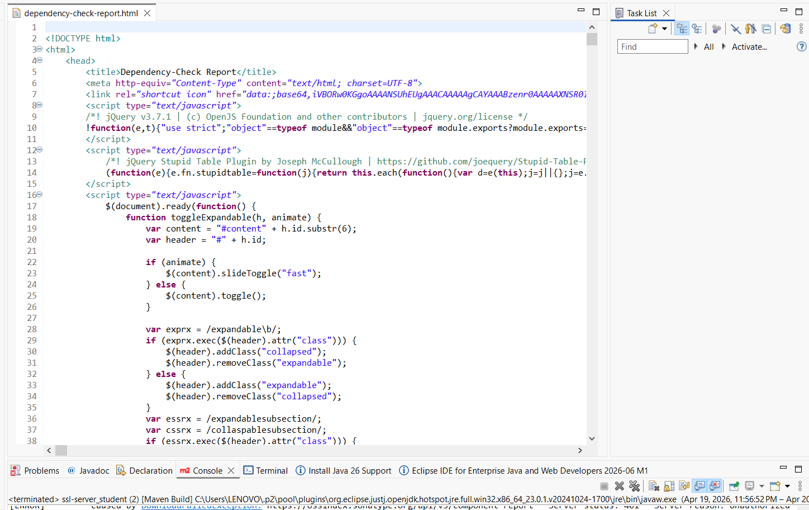

Functional Testing
Insert a screenshot below of the refactored code executed without errors.

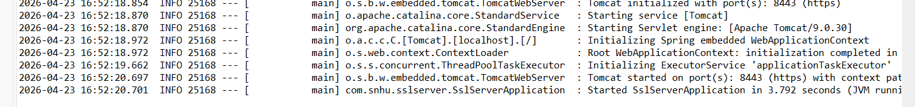

Summary

The Artemis Financial project was improved by adding secure communication features and modern security controls. HTTPS was configured using an SSL certificate, and SHA-256 hashing was implemented to demonstrate checksum verification and data integrity. Dependency scanning was also completed to identify outdated or vulnerable libraries. Testing confirmed that the application runs successfully and provides a more secure environment for users and financial data.

Industry Standard Best Practices

Industry standard best practices include using strong encryption such as AES-256, enabling HTTPS with valid certificates, protecting data integrity with SHA-256 hashing, and regularly scanning software dependencies for vulnerabilities. Developers should keep libraries updated, follow secure coding standards, test applications before release, and apply least-privilege access controls. These practices reduce security risks and improve system reliability, privacy, and trust.

